

Labotary Exercises

CST2310: Data Management and Business Intelligence



M00810926

Middlesex University

Abdullahi Mohamed

**Contents Page**

**Week 1 Lab Work CST2130 Intro – Page 3 to 6**

**Week 2 Lab Work CST2130 Addressing Lab – Page 7-12**

**Week 3 Lab Work CST2130 TCP – Page 13-17**

**Week 4 Lab Work CST2130 Keeping the Machine Fast Lab – Page 18 – 22**

**Week 5 Lab Work CST2130 Disaster Recovery Planning Lab – Page 23-29**

**Week 23 Lab Work CST2130 Data and Metadata – Page 30-45**

**Overall Conclusion on Block 1 Coursework – Page 46-46**

**Week 1 Lab Work CST2130 Intro**

**Introduction**

In this question, I will be displaying my experience on Wireshark and explaining the purpose and ultimate motive for it.

**Explain why it is important to open Wireshark with the Promiscuous Mode turned off.**

The reason it is important to turn off promiscuous mode is because it will only send and receive packets on your device only, had it turned on you will have access to everyone else internet activities. Therefore, on your device it is necessary to turn off Promiscuous Mode. To turn if off you click on edit, then click on to a preference, press capture and then remove the tick from it. This is a security policy to protect each user’s privacy and helps ensure all network traffic is from your device.

**Explain what you see when you open Wireshark?**

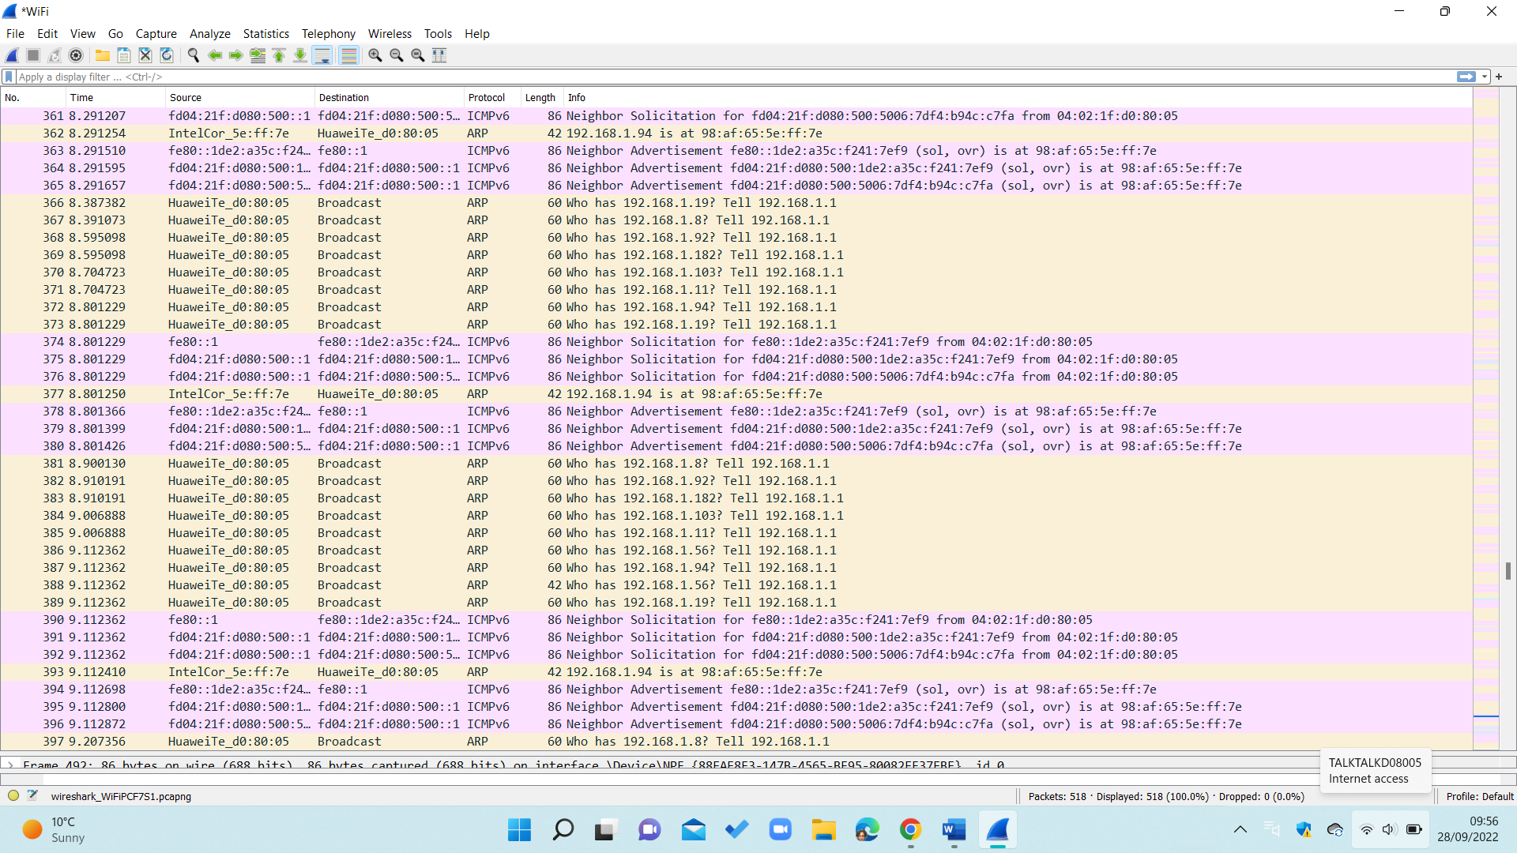When I opened Wireshark, I saw an option to click on one of the network connections, after I chose one. It recorded my network activities in seconds, all in real time. This is unsafe personally as I believe my internet activities should be all private to ensure that all transactions and browsing, I do should be secure.

Above it shows the time, source, destination, protocol, length, and gives a brief description of the network traffic. Down below is the Hexadecimal of the Wi-Fi Packet, its use is to read packets and capture files. All these protocols are from my internet browser to which I can investigate separately each packet, hence it provides useful information that I have looked through.

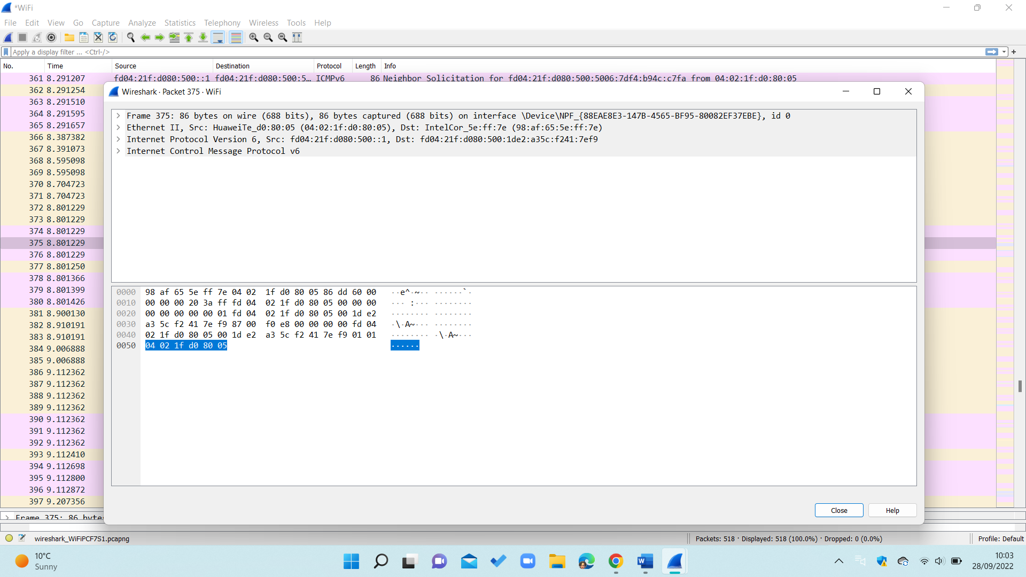

Above is a Wireshark packet that display the type of network, protocol, and the result in hexadecimal.

**What sort of protocols can you see?**

I can view protocols, one of the following is TCP, it is one of the most common protocols. It is communication between a client and server. Another protocol I saw is ARP, it connects the IP address to a physical machine address. This Protocol is for security as its role is to prevent transactions made by hackers.

**Is it easy to understand what you see?**

It is easy to understand because Wireshark the layout is clear and the structure of it allowed to me understand it. For example, it separately groups each network packets all in column and row format to inform of all the transmission on my device. I learnt how to search for one protocol and gather all the result, this demonstrates the variety of Wireshark and how you can venture on the software through spending time on the software. A clear tutorial that can be used for everyone that shows you how to follow a stream, display filters and anything related to the network packets. This has helped me figure out what to do on the software within an hour of using because there is a great understudy from the teaching.

**How can you follow a stream?**

To follow a stream, you need to right click on a protocol and then it will show the streams connected to it. This can help figure out a hidden password or making dues with the current network you are researching.

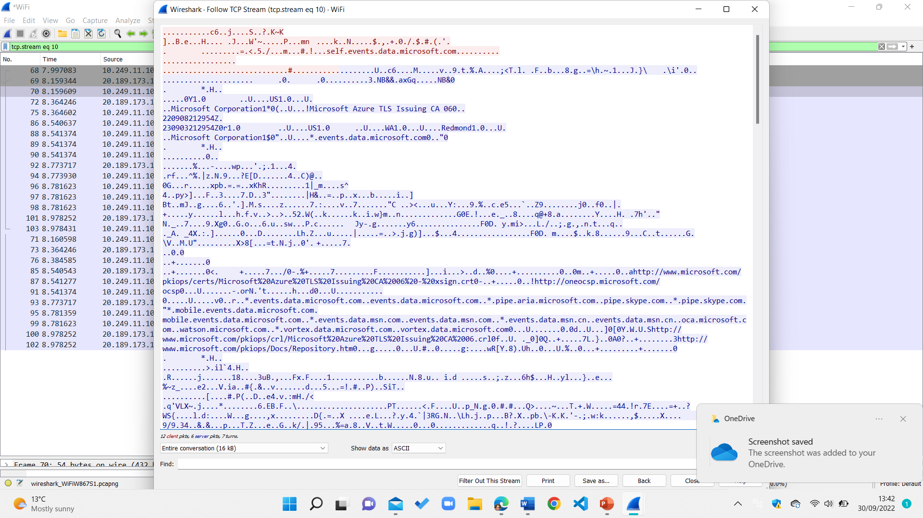

**Can you filter to view packets only from specific sources or destinations?**

To filter a view packet, you need to click on analyse, then click on display filter on your network packet. This then will out print the filter name and expression.

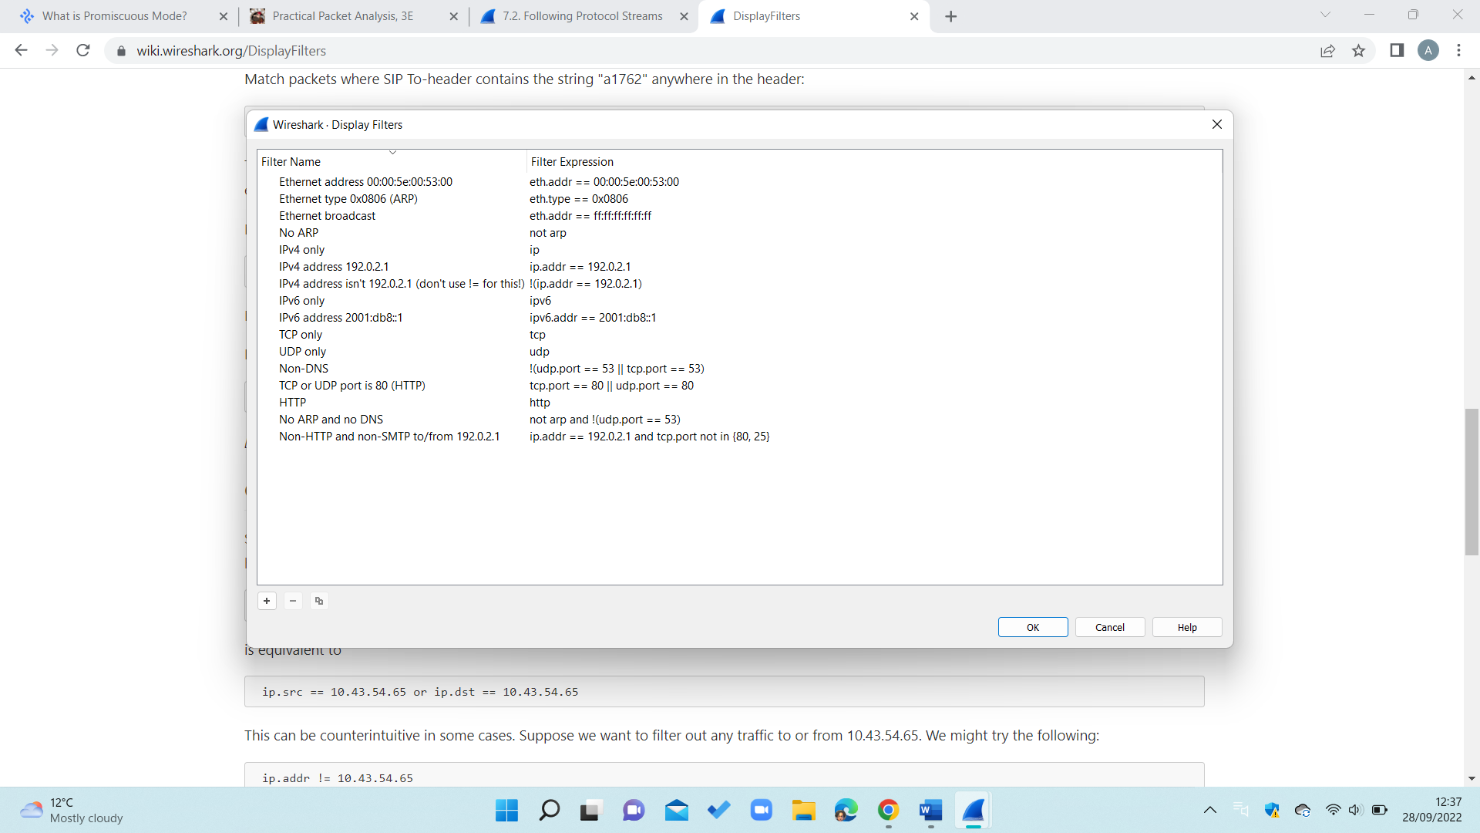

Display filters centres around one protocol, this states the filter name and expression to which I can identify why type of protocols with which I am dealing. This is done to display a particular stream and can press cancel to go back to all the network packets.

**Should this software be freely available – considering its potential for misuse?**

I believe that the software should be a subscription based which listed all the risk factors of using it. The potential of misusing is Wireshark can lead to imprisonment; this highlights the endangerment of using incorrectly therefore it should not be accessible to everyone. Another reason I believe it should not be free because there should be a user authentication to prove the individual, this can prevent any long-term issues of misuse act.

**My opinion on Wireshark**

I will be listing my thoughts down below on Wireshark, I will be being with the positive

* One positive of Wireshark it is free, therefore it is applicable to all types of people with a device. This helped me as a new user who is unsure of purchasing a software to troubleshoot network, instead of having to purchase a software instantly.
* Another positive of Wireshark is there is a clear tutorial to help anyone struggling of using the software, by having instruction to follow it prevents confusion and has helped navigate easily on the software.
* The third positive of Wireshark it goes into detail thoroughly on each packet network, which helped understand what the browser search.

I will now be listing the negatives on Wireshark to which I have my reason for.

* The accessibility of Wireshark is far too common to which the data can spread to wherever and lead to consequences.
* Another problem I faced using Wireshark was I could only receive the data and not being able to send it, this being it is a one-way service and lacks cooperative.
* The last difficulty I faced using Wireshark that I had redo capturing networking packets because I could not get all the common protocols in one capture.

Overall, I believe the positive outweigh the negatives in Wireshark because it is free meaning everyone can be use it, it identifies all the internet activity and notice anything that is wrong with your internet search. Lastly, the usability of the software is flexible and understandable to which I learnt instantly on how to capture and a network, following a stream and displaying any filers.

**Question I have asked on intro of Wireshark**

* If promiscuous mode is not turned off who will be alerted?
* How much detail of each protocol is for a display for user?
* What is the main goal for Wireshark developers, is it marketed regularly?
* To Wireshark charge any sort of fee for those wanting to become an expert at it?

**Conclusion**

To conclude, in this laboratory I have covered all elements of Wireshark to which I am a lot more comfortable explaining on what to do with Wireshark and can explain the key functions.

**References**

Chris Sanders, 2015, Practical Packet Analysis, viewed October 9th, 2022, < file:///C:/Users/Abdul/Downloads/Practical%20Packet%20Analysis.pd

Wikipedia,2022, TCP, viewed October 9th2022, <<https://en.wikipedia.org/wiki/Transmission_Control_Protocol>>

Fortinet, 2022, What is Address Protocol: viewed October 9th 2022,<<https://www.fortinet.com/resources/cyberglossary/what-is-arp>>

Wireshark User Guide,2022, Hex Dump, viewed October 9th, 2022, <<https://www.wireshark.org/docs/wsug_html_chunked/ChIOImportSection.html>>

Wireshark, 2022, Frequently Asked Question, Viewed 9th October 2022, <<https://www.wireshark.org/faq.html>>

**Week 2 Lab Work CST2130 Addressing Lab**

**Introduction**

In this lab I will be analysing protocols to which I will be informing potential users about each, in all I be going to detail for an in depth understanding.

**Info on ARP**

ARP stands for Address Resolution Protocol; it authorizes both logical and physical addresses for connecting on a network. Logical address can help communicate to networks and without knowing connect devices together. On the other hand, Physical addresses is a real street which could a personal or business residence.

**ARP Packet Structure**

Hardware of ARP: usually it is Ethernet.

Protocol Type of ARP: A high layer of protocol is in use

Address Length of ARP: The length of the hardware is in use

Protocol Address length of ARP: The length if the logical address

Sender Hardware Address of ARP: The address of the sender

Sender Protocol Address of ARP: The senders protocol address

Target Hardware Address: Intended receiver hardware address

Target Protocol Address: The intended receiver upper layer protocol address

**ARP Request**

Their role is to request to all machines on the LAN and to question any engine that uses an IP address. As soon as it spots the IP address it sends a reply to ARP to update the cache and continue with the communication.

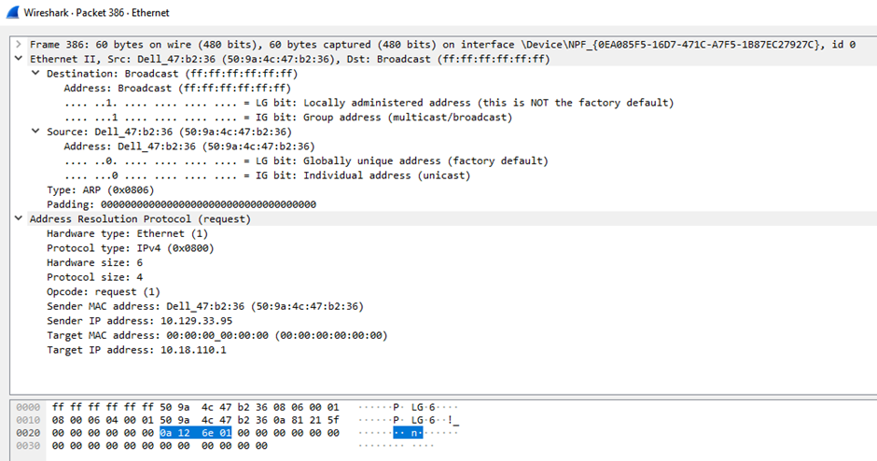

Above is a screenshot from an ARP packet that lists all the following, hardware type, which is Ethernet, it is for connecting systems together on LAN with information passing through.

The protocol type in use is IPv4, it is the fourth version of the internet protocol.

The output of the ARP request shows the destination which is the system of receiving data. It is the reply rather than the request.

The output of the ARP requests of the source can be a use to send data. All information is present to which there is a host.

**ARP Packet Details**

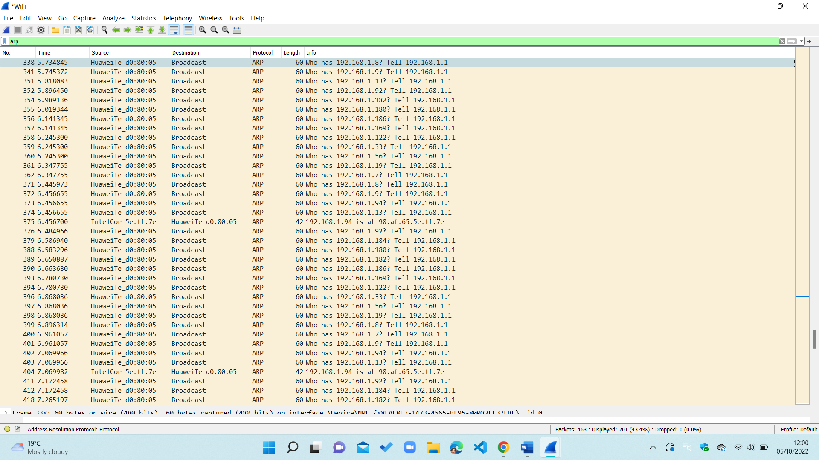

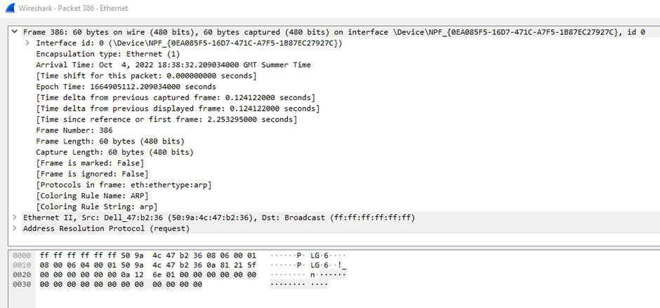I have used the search bar to solely search for ARP, above is a screenshot of the number, time, source, destination, protocol, length, and info. I managed to capture 390 protocols in real time, to which are the sources of HuaweiTe_d0:80:05 (04:02:1f: d0:80:05), this is a common tool to send data on my device. Majority of lengths in my ARP is sixty because the network interface card is to receive packets on Wireshark.

This above diagram portrays the frame of ARP, for example it states the arrival time which detects in real motion. This is a useful matter as it lets me understands the use of the protocol, in addition it highlights previous capture and display, this both gives the seconds in real time to ensure the reliability of the search.

**Gratuitous ARP**

It is an ARP response without an ARP request, it can be a use to send a broadcast to which can update the network. Both source and destination IP address are set to the IP, Mac address is the broadcast Mac address, it is a generate by network device such as replying.

**ARP Cache Poisoning**

It is a fake ARP reply to packets to gateway over a local network. Hackers usually use spoofing tools such as Arp spoof, they set up the IP address to match the tools of their target, it then scans the targeted LAN for the IP and Mac addresses. When the targeted user communicates, the message will send to them. They usually would use the denial-of-service method, which is sending request to the target to disrupt the service.

**What is DNS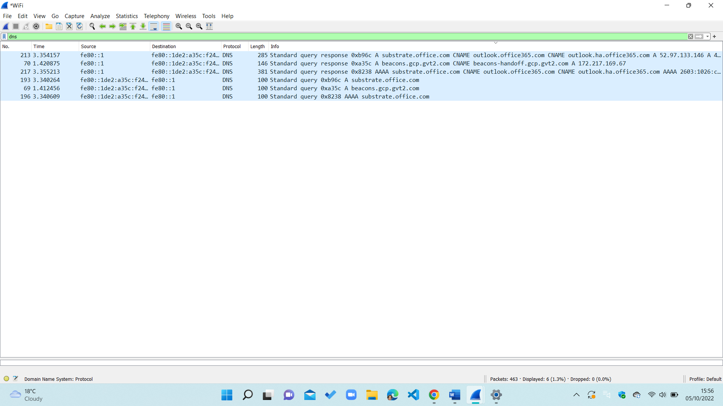?**

DNS is known as Domain Network System; its purpose is to help users on network devices to find hostnames instead of IP addresses. The second step in a DNS protocol is a request by a resolver, it is a server created to install from web browsers. Also, it is accountable for matching the IP address for the hostname, this is known as the DNS request. The third process is known as the root server, it must move downwards to the server, so that specific domain is example.com. When it reaches the authoritative DNS name server it demonstrates the IP address and returns to DNS client. Finally, it the client can connect to the server using the correct IP address.

I only managed to capture six protocols, this is because it is a lesser common protocol than TCP and ARP. Therefore, the information is less but more precise and direct, for example on the first line it highlights the exact search words I put in the info section. The source and destination are the identical, this is due to receiving and sending data. This protocol can traffic capture the database at an easier than other, it is in a light blue colour frame by default.

**DHCP**

It stands for Dynamic Host Configuration Protocol which is a protocol that is based on unlocking machines such as gaming consoles. It has the functionality to request the Internet Protocol information from a server passively. Usually, it is part of a home network and it request Internet access that finds information of the Internet Protocol.

**DHCPV4**

IPv4 became a solution to network configuration to node internet access, it has been since the early nineties and became established by the late nineties and is worldwide till today.

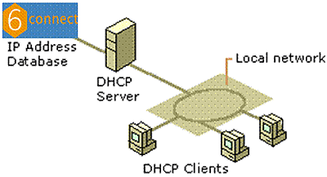

Above is a diagram of a typical DHCP diagram:

Circled Master, 2022, IPV4 VS IPV6, Viewed October 9th, 2022, <[**https://circleid.com/posts/dhcp_for_ipv4_vs_ipv6_what_you_need_to_know**](https://circleid.com/posts/dhcp_for_ipv4_vs_ipv6_what_you_need_to_know)**>**

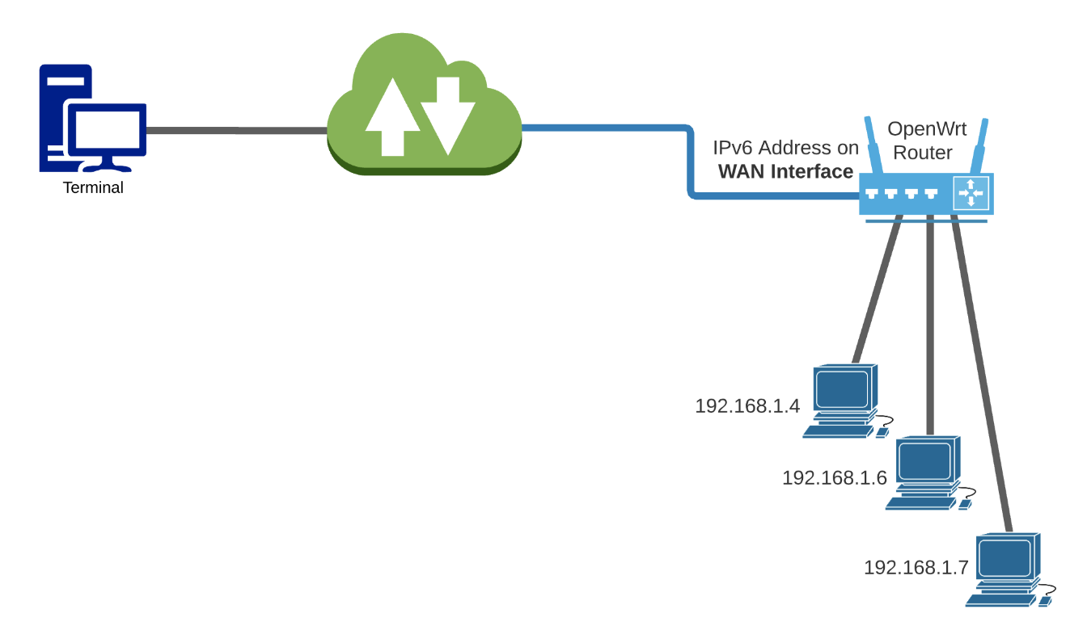It is an act to send a message to local area network and request information to store securely. Down below is a diagram of it

OpenWrt,2021, Routing from ipv6 to ipv4, Viewed March 2021,< <https://forum.openwrt.org/t/routing-from-ipv6-to-ipv4-only-stations/90363>

**DHCPV6**

IPv6 addresses are 128bit in the length, it is also a unique IP address in which is faster than most protocols. It is an updated version of IPv4, meaning it is a new and improved.

**Differences**

Differences between both is that IPv4 has a 32-bit address length, whilst IPv6 has a 128-bit address length. IPv4 supports manual configuration, whilst IPv6 supports auto. The classes for the fourth version, on the other hand the latest version does not have any IP address.

**ICMP**

It stands for Internet Control Message Protocol; it is a protocol for problem solving in transmission data. When it comes to errors, it is a tool to report and execute distributed denial of service. It gathered information regarding the number of devices available for users.

**ICMP Packet Structure**

Type: it is a classification of ICMP message based on the RFC.

Checksum: Used to ensure information of ICMP data that arrives

Variable: A portion can be a variety on the type.

**Traceroute**

It is to identify from one device to another, used to trace the path of an Internet Protocol.

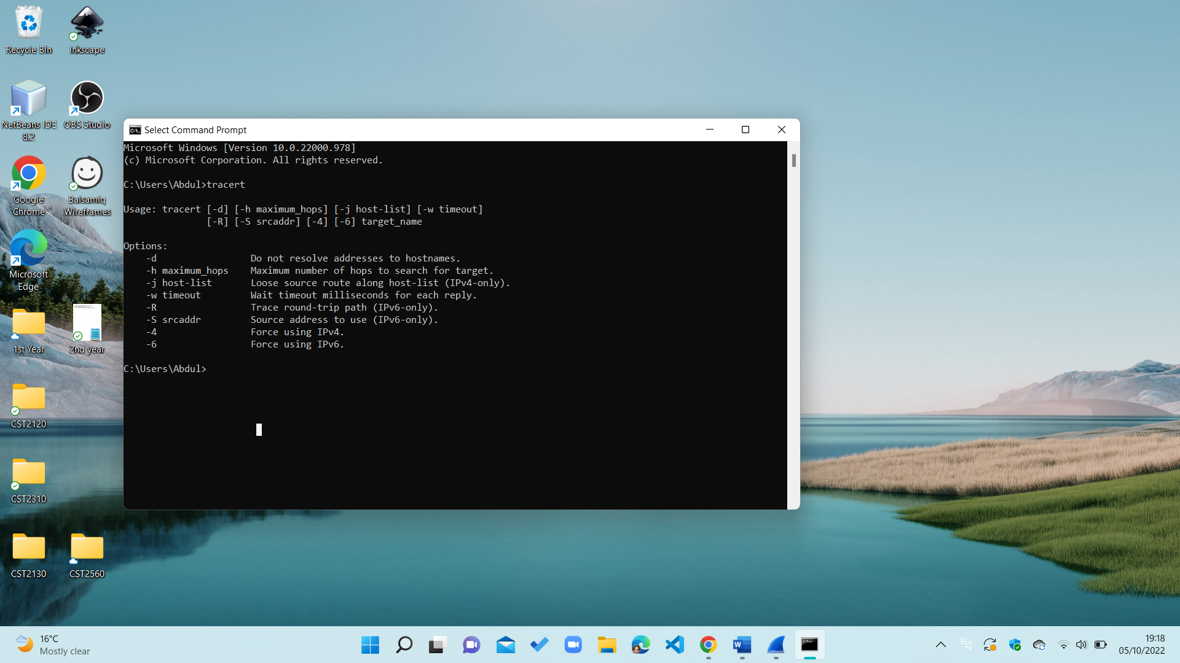

Their above is a screenshot of command prompt that states of Internet Protocol, it shows the path it and the time it took.

**Ping**

It is a source host sends a packet to the targeted IP address; the program is responding to the host. It allows a user to evaluate and verify if a particular destination IP address exists and can accept requests in computer network administration.

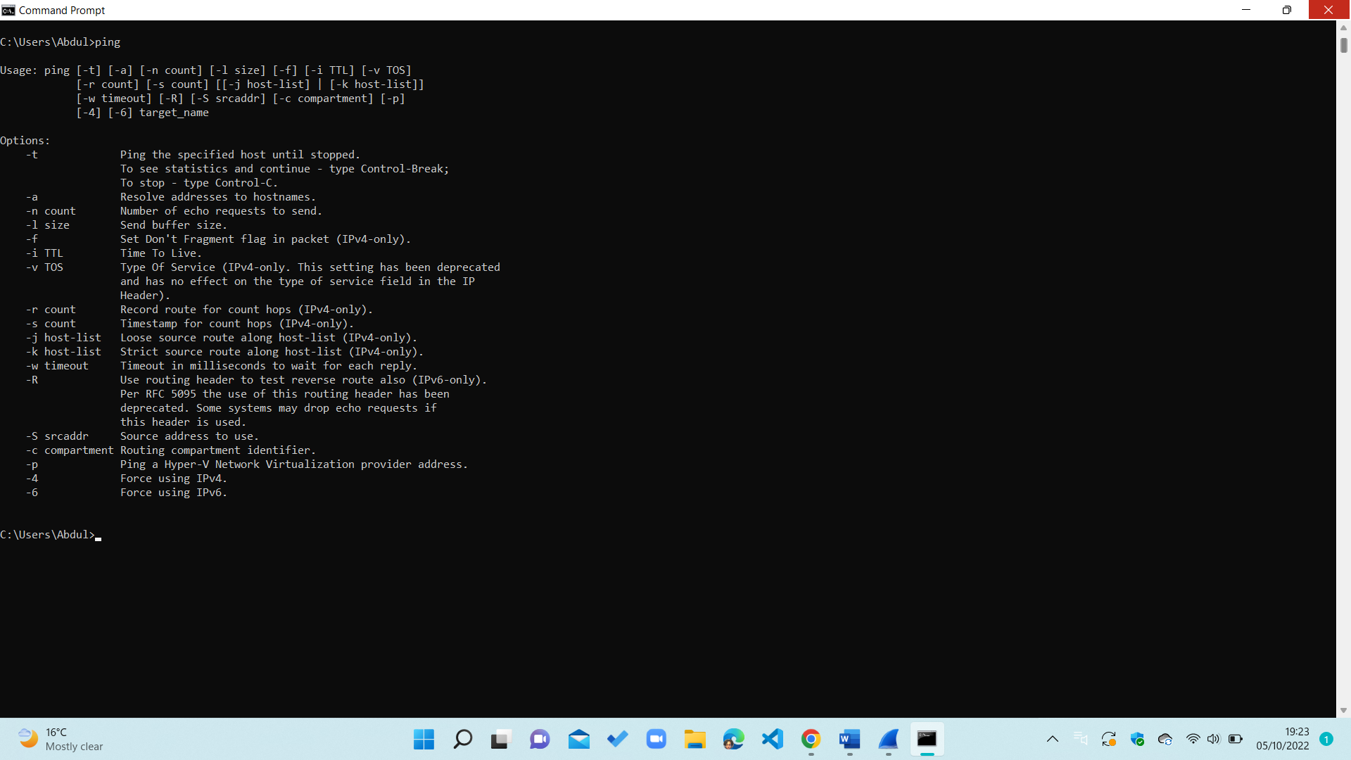

**Delta Time**

This is used in TCP; they measure to time elapsed between the prior and the current packet. In Wireshark, you select edit and then press preference.

**Packet Header**

It is the bulk of an Internet protocol pack that contains addresses and many more precise data that is needed to reach a set destination.

**Time to live**

It means the amount of time that a packet exists in a network before it is removed from a router, it can have a maximum of an eight bit.

**Opinion on Addressing Lab**

I believe that I have discovered new protocols through trial and error because I now can display any protocol through filtering.

Above I covered plenty of protocols to which I attempted in Wireshark and provided screenshot; it taught me the purpose of each which is informative.

I have given detail to help a new a user who has no former recollection of Wireshark to which they can manage on the software.

I would recommend the protocol to anyone needing a further information on their web activities, this can help anyone confused of them.

**Question I have asked on Addressing Lab**

How would a new user know how to filter a protocol in Wireshark?

How would a new user download Wireshark without any technical skills?

If the capture never stops what will happen to the protocol?

Is their other software that protects personal data more than Wireshark?

**Conclusion**

To conclude, I have discussed the addressing of protocols in Wireshark to which I have displayed, facts, figure, pictures in real time for everyone to understand the purpose of it.

**References**

Practical Networking .net, 2022, Gratuitous ARP, viewed December 10th, 2021, <<https://www.practicalnetworking.net/series/arp/gratuitous-arp/> >

Wireshark q&a,2022,how the source and destination is identified, Viewed 9th 2022,< <https://osqa-ask.wireshark.org/questions/1863/how-source-and-destination-is-identified/>>

Chris Sanders, 2015, Practical Packet Analysis, viewed October 9th, 2022, < file:///C:/Users/Abdul/Downloads/Practical%20Packet%20Analysis.pd>

NS1,2022, DNS Protocol, Viewed October 9th, 2022, <<https://ns1.com/resources/dns-protocol>>

CircleId Master, 2022, IPV4 VS IPV6, Viewed October 9th, 2022, <<https://circleid.com/posts/dhcp_for_ipv4_vs_ipv6_what_you_need_to_know>>

**Week 3 Lab Work CST2130 TCP**

**Introduction**

In this question, I will be thoroughly going through every aspect of TCP protocols to alert anyone that is interested in protocol for personal or technical use.

**What is TCP?**

TCP stands for Transmission Control Protocol; it is a communication method that allows application programs to interchange messages over a network. It sets rules of the internet and is usually within digital network communications.

**TCP Stream**

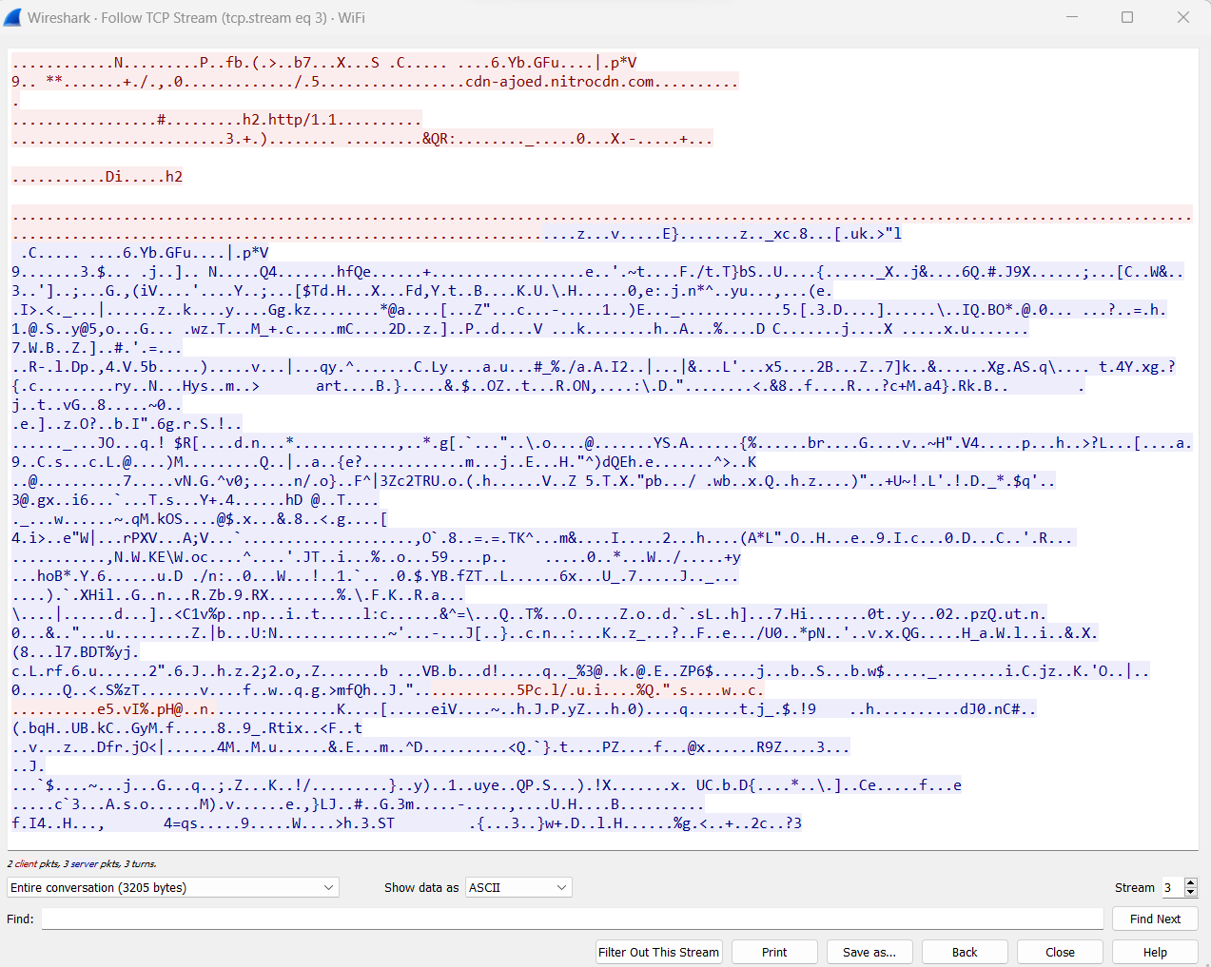

The use of a TCP stream is to follow a particular conversation stream between hosts, in the screenshot is TCP packets between the source and destination, it is data that is sent to an exchange. On the second row, there is the website details which is a nitro pack, it has assembled data which the sender can send however much whilst the receiver receives everything.

**TCP Packet Structure**

Flags: ACK, URG, PSH, RST, SYN and FIN are the types of flags transmitted.

Destination Port: it is the port to which the packets will transfer to.

Sequence Number: It is the number used to identify a segment and to ensure that parts of the data are not missing.

Source Port: The port to transfer the packet.

Window Size: The size of TCP receives buffer in bytes

Option: Variety of options field that is in a TCP Packet

Acknowledgment Number: the sequence number is the next packet.

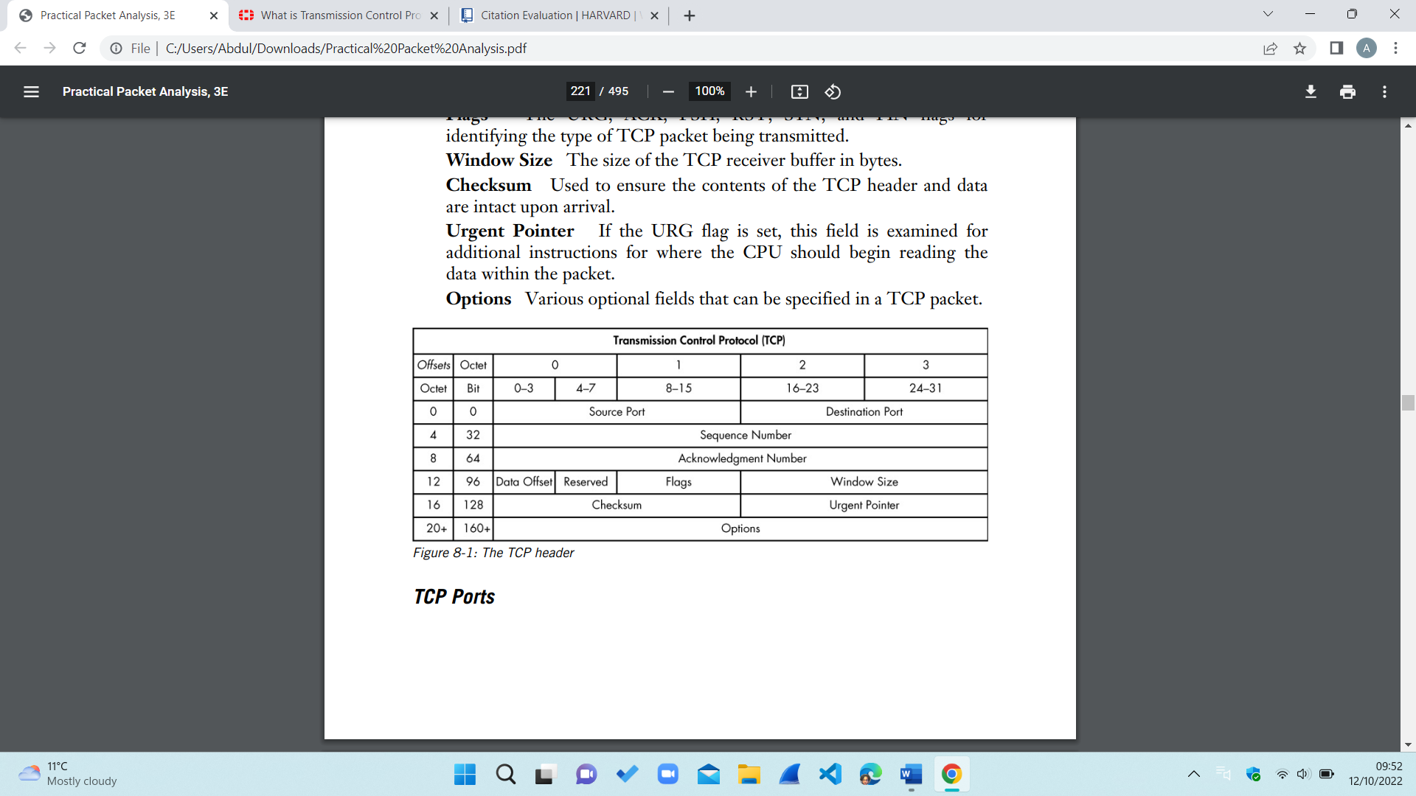

Source port is fifteen bits which is equivalent to 1.9 bytes.

The sequence number and Acknowledgment Number is thirty-one bits which is equivalent to 3.9 bytes.

Data Offset is three bits and reserved is equal to 0.4 bytes.

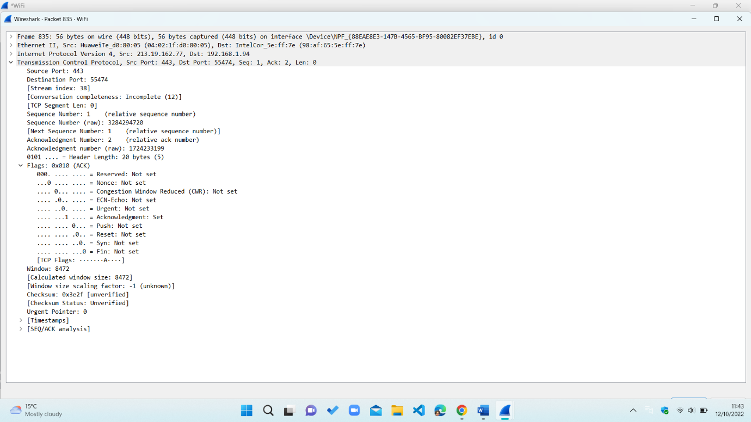

2

1

4

3

In this screenshot it portrays a TCP packets, the first two values are source port and destination port. The packet is from 213.19.162.77 to 192.168.1.94, the source port is 443(1) and the destination port is 55474(2).

**TCP Three Way Handshake/Analysis of Results**

It must be with two host; the requirement is to ensure the recipient is able to communicate and the host is to check if they are listening on the port. This allows the host to send sequential numbers to the receiver so both have a stream of a packets.

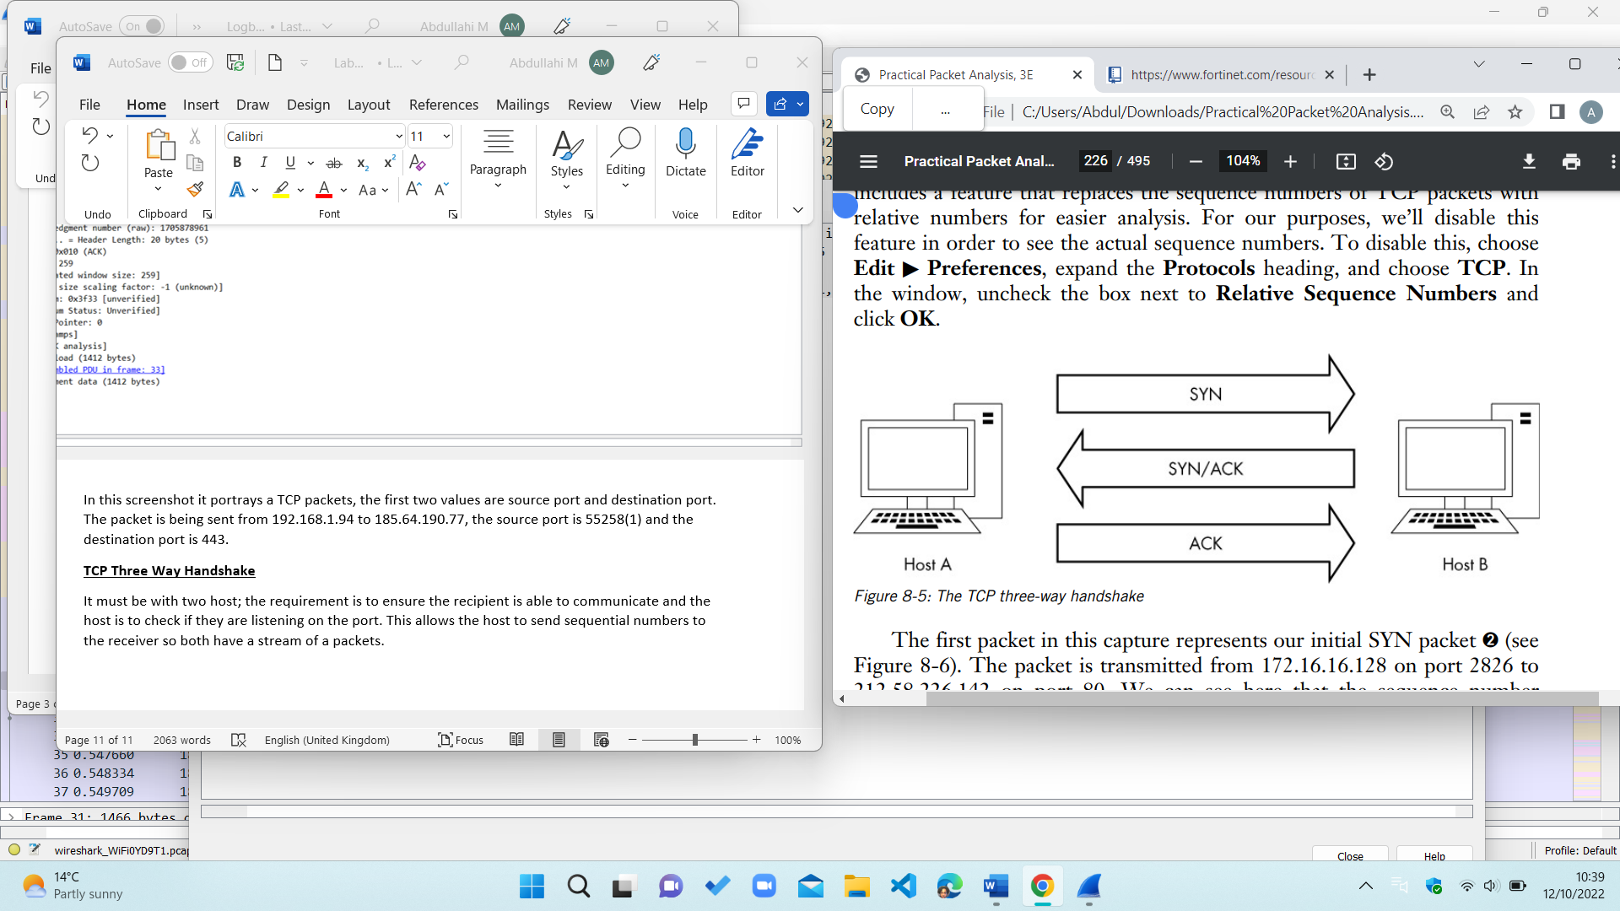

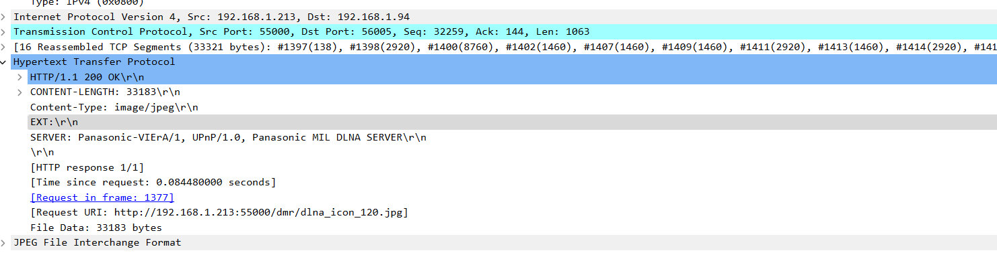

Above is a diagram of a TCP three-way handshake, The computer on the left sends a TCP packet to the computer on the right. In the beginning there is no data apart from the lower layer protocol, SYN flag synchronizes sequential numbers to start a connection. Host B responds this packet by sending ACK and STN along with the sequence number. Finally host a sends a last packet to host b with only including ACK flag. When all information is process, the system should be ready to communicate. I have a capture of a three-way handshake to which it provides the content type that is a jpeg image. It is a TCP protocol that provides the segments, server, time request and more data types.

The first packet in the capture is SYN stands for synchronize and is establishes a connection between them. The packet transmits from 213.19.162.77 on port 443 to 192.168.1.94 on port 55474, to which the sequence number is 3284294270.

The second packet in the handshake is SYN and ACK response, from 192.168.1.94. it also shows the sequence number and the acknowledgement number which is 1724233199. In my screenshot above of my results on Wireshark, this stage of the three-way handshake is for specification of the next sequence number which the host expects to receive.

The final packet is ACK, from 213.19.162.77 to the sequence number which is 3284294270.

**Final ACK**

**TCP Teardown**

TCP teardown is to slowly end a connection between two devices after they have finished communicating. This process involves variety of packet, the first stage is FIN/ ACK, they aim of is to finish communication between hosts. Host B then replies with an ACK and transmits their own FIN/ACK packet. Host A finally responds with an ACK packet to end communication between both parties.

**TCP Incomplete Teardown**

An incomplete teardown occurs through vulnerability in the protocol, and there is no reply between the hosts.

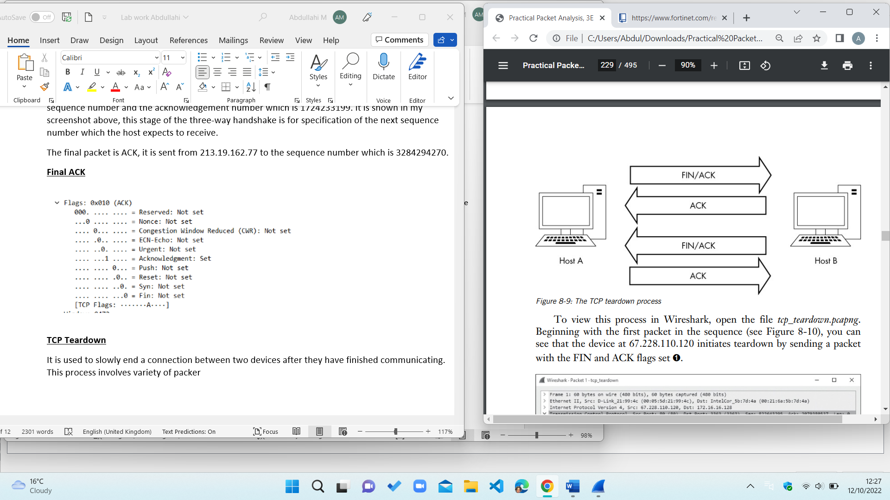

**HTTP GET**: it requests representation of the specified resource and should only be in use to request data. It used to retrieve to request data from a specified in a server, it is the one of the most popular HTTP requests.it can remain current history on the network and cache it.

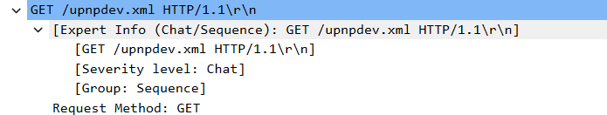

**HTTP OK**: it is a responsive code that indicates the request has been a success, the resources will be fetched and transmitted. Used for indication of a succession of a server and that it is fully loaded.

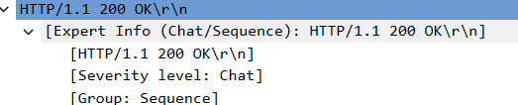

**Opinion on TCP**

**I will be basing my thoughts on TCP on what I have discussed in above. Starting with the positives.**

* It is a common model used in any networking problems to which a new user facing any trouble they can apply TCP
* It can be applied to any scenario in any technical field, it allows the network to add current services with disturbance.
* An IP address is used for all computer network, name and address is provided therefore it promotes safeness.

**I will now be going through the faults of TCP.**

* When TCP were first introduced, they were not an instant use, it took about 30 to 40 years for the protocol to become a renowned network packet.
* It does not specialise in any area, they main fault being it cannot display a Bluetooth connection.
* It was at first designed for wide area network which now it used for the complete opposite local area network.

**Questions I have asked on TCP**

How will a new internet user grasp the concept of TCP without no technical background?

Is TCP protocol an out-of-date protocol, is it being pushed in mainstream media?

Are they alternative protocols that are better than TCP?

**References**

Fortinet, 2022, What is Transmission Control Protocol, viewed October 12th 2022, < <https://www.fortinet.com/resources/cyberglossary/tcp-ip> >

Chris Sanders, 2015, Practical Packet Analysis, viewed October 9th, 2022, < file:///C:/Users/Abdul/Downloads/Practical%20Packet%20Analysis.pd>

**Conclusion**

I have covered points of TCP and all the factors surrounding the protocol to which I have explained in detail. TCP is quite dependable, ensures the data is reached, enable connection to the internet and will recommend this protocol to any user. In addition, I have outlined any faults with using TCP to warn a new user for any difficulties they may face in Wireshark.

**Week 4 Lab Work CST2130 Keeping the Machine Fast Lab**

**Introduction**

In this question I will be listing all the feasible way to keep your machine up to standard, this will be done through dependable and referenced research. All of points will be backed up with reason to which a new user would understand my thought process for it.

**My Personal Machine**

A way I keep my machine fast is by consistently **updating my software**, in which there has been plenty of benefits for it.

* **Secure**: the first reason is to always ensure security because hackers can see my systems and can choose to attack it. They can detect my computer and steal data from my device and gain access to my files.
* **Protection**: Another reason I consistently update my software is to keep all my valuable information such as my passwords for websites protected. If not protected, cybercriminals can access and encrypt data to then commit crimes with it.
* **Personal Choice**: I regularly update my device to have the greatest possible experience on my laptop, it is their will be less faulty and is more stable in performance.
* **New Features:** A way I keep my machine is using the new features through updating my software regularly. This helps me have an enjoyable experience on my laptop to which it can improve if I keep updating my machine.
* **Bugs:** I update my software to preventslowness when browsing**.**

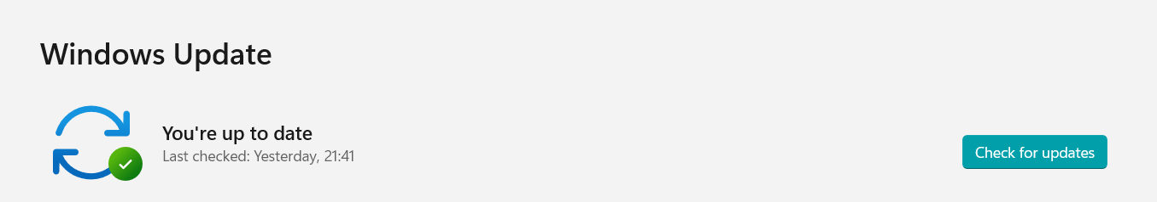

A tool I use to keep my machine fast is by **uninstalling any application** that I no longer or use to a minimal

* A benefit of this to save battery and optimises current in use application because there is now more storage available.
* Having more storage can help me install application of my choice.
* Less likely to overheat due to the device having more space.
* Another is deleting application which is used on my mobile phone instead of taking up storage on my laptop.

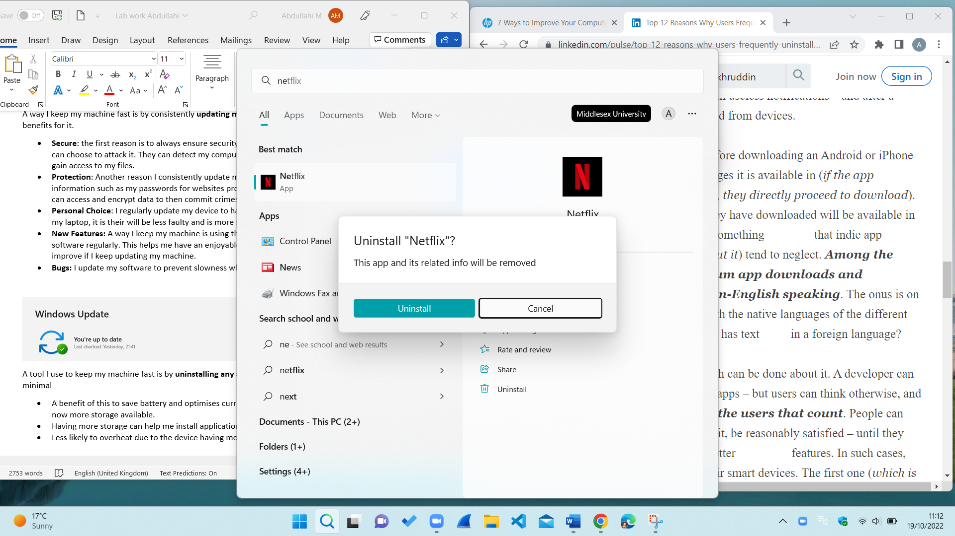

The third way I keep my machine clean is by **clearing the cache** of my internet browsing.

* Helps protect personal information
* Application on my laptop usually run a lot faster
* Information from websites is cleared meaning that my details are not stored.

This tool has helped always keep my laptop clear and has benefits such as data protection. I notice a difference after clearing the site data as my device is more responsive due to having more cache.

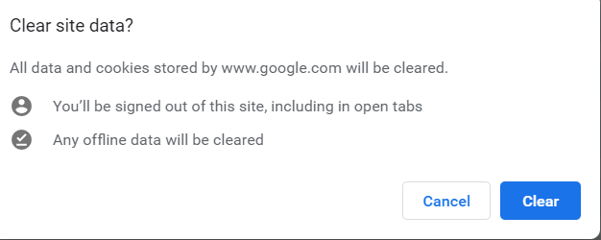

The fourth way is keeping my machine up to standard is restarting my laptop

* One reason is because many applications are left opened, leading my laptop feeling unresponsive hence restarting it can cure it.
* It also pauses the processor and focuses on which tasks needs to be done.
* It allows the laptop to reset the machine to which it can speed the use of it.

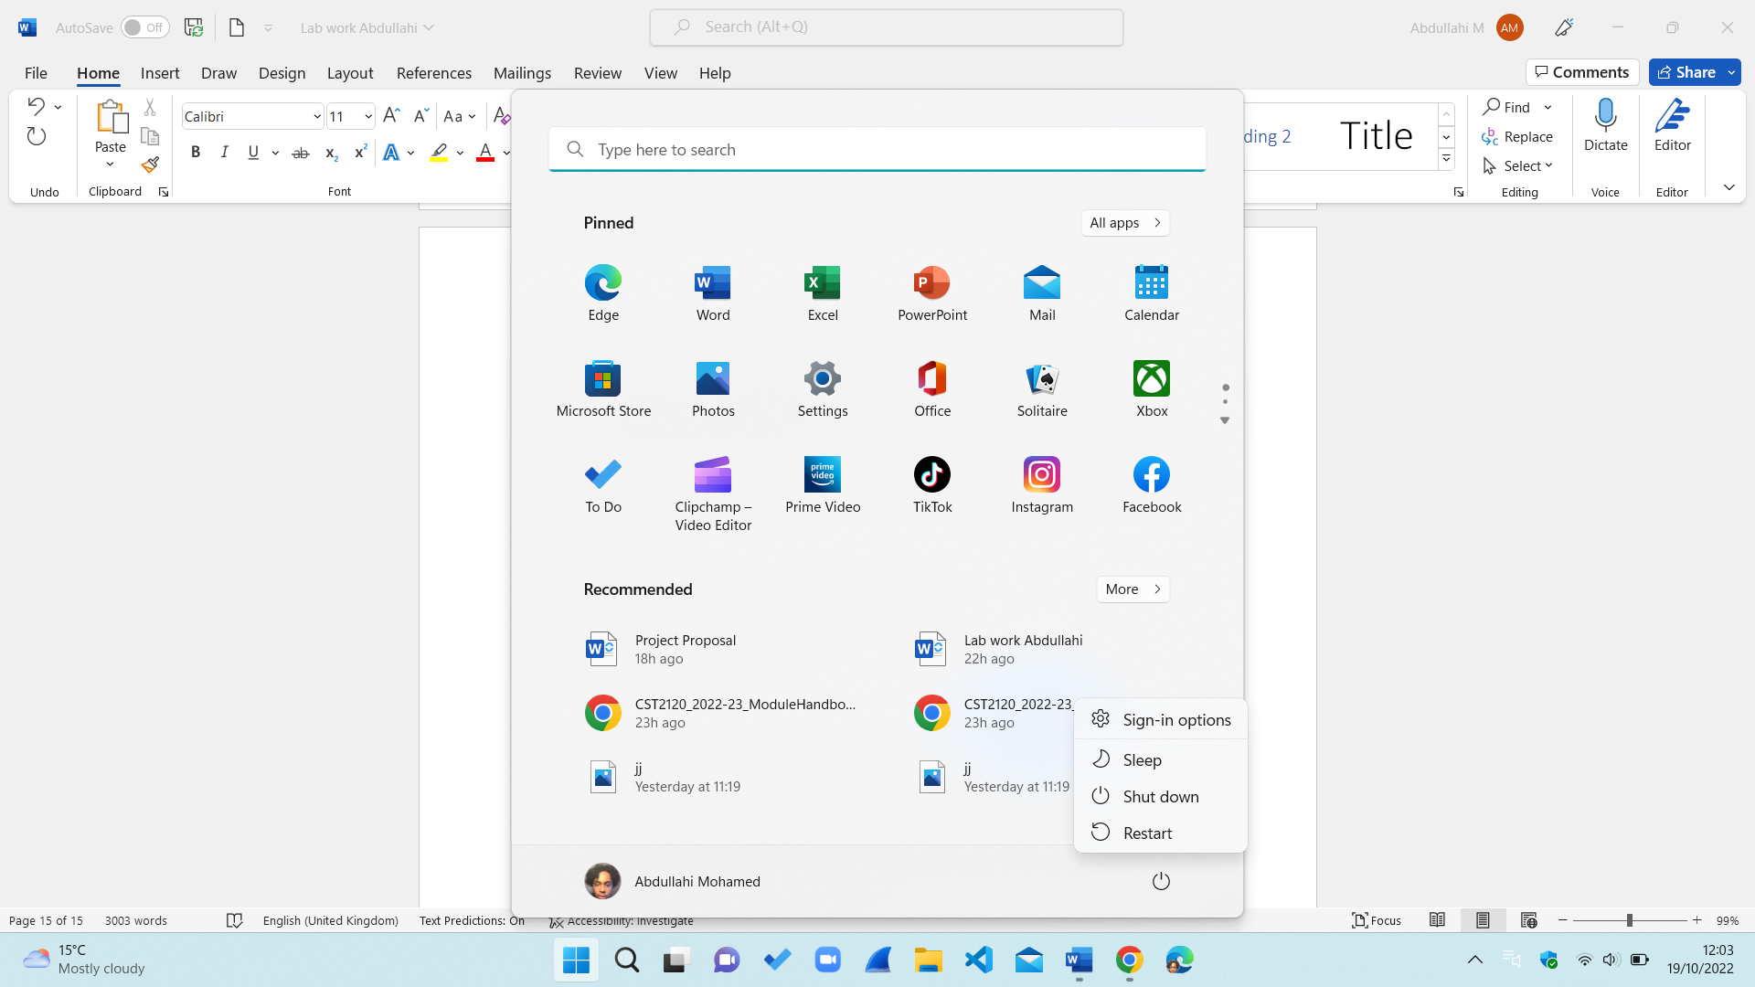

The way I assess if I the application can be trusted on my device is to see the reviews of it, this helps me build a rapport knowledge of the application. Depending on the review I then decide whether it is useful for myself, this is when I delegate how time will I spend on it. Then I make my final decision on whether I should download this application or not.

The fifth way I keep my machine as fast as possible is by having an **anti-virus software** protection service.

* Preventing phishing
* Provides a warning on an unsafe website
* Usually helps have a safer time online
* Includes password encryption

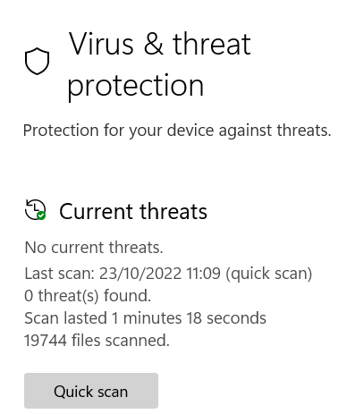

Another way that I keep my machine fast is by limiting **start-ups application**, this means the amount of application that automatically run when I start my laptop

* Improvement of performance due less application running the background
* Prioritizes application that user chooses to suit their needs
* User control allows full control of the device.

I believe that the less start-up application it has improved the pace of my machine when browsing. In addition, I have full accessibility to turn it on or off whenever which is a benefit to my machine.

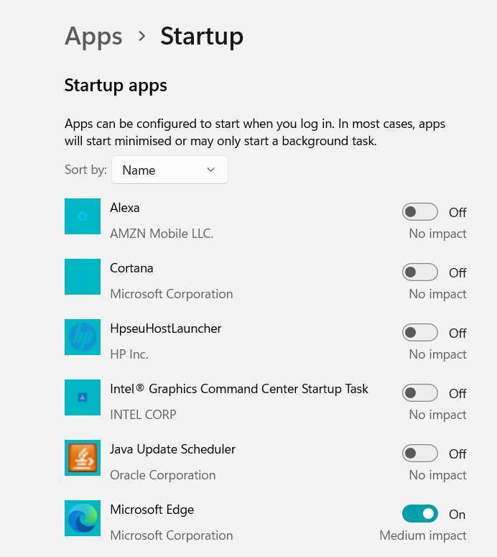

A way I keep my machine up to my standard is **deleting old/unused folders** of work, this clears up storage.

* Reduced disk space
* More Storage
* Unnecessary document gone

This method has allowed me to always have spare storage, little to no overheating and a faster operation on my laptop.

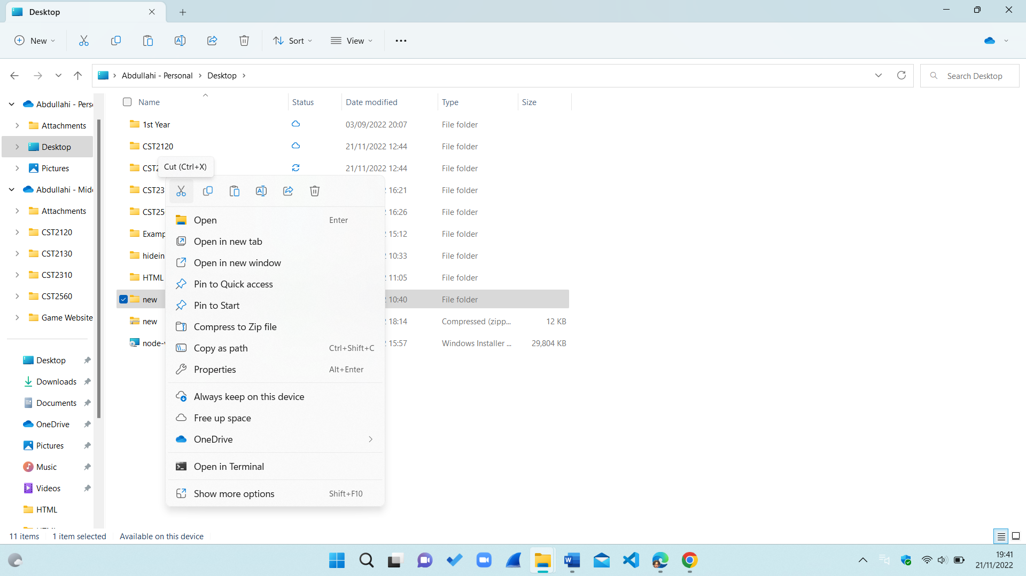

The final way I keep my machine fast is by **closing tabs** that is longer in use.

* Translates into better performances
* Web pages load quickest with a single tab open
* Easy to visualise what you need as of now

This method has been beneficial because my laptop is at its quickest when I have one or a few tabs opens compared to having ten open at once.

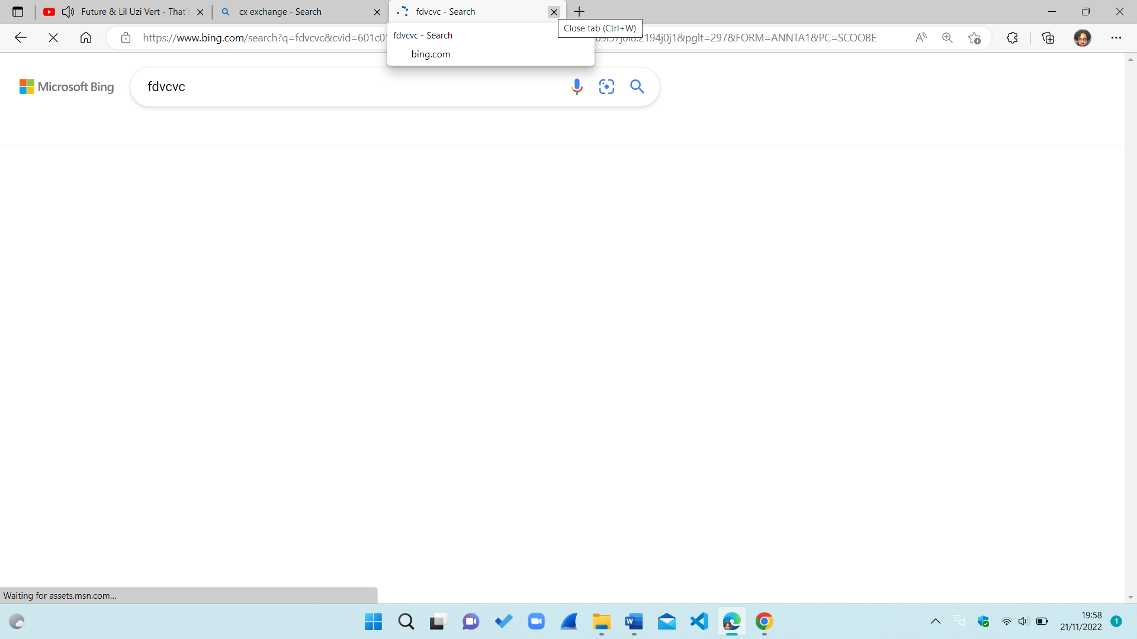

**Opinion on keeping the machine fast**

All the methods I mentions for keeping a machine I genuinely believe that it will help the performance of your device because of its reliability and proof. I will be recommending any of the following I suggested for keeping your machine up to your desired pace. This is because I have seen a major difference in my daily activities on my machine, therefore I would suggest this anyone especially anyone in the IT industry. Through research I have now implemented more of these examples that I stated in above into my devices and I have instantly felt a difference in my device. The most useful one being turning off as many start up application as I could. This instantly gave my laptop I necessary boost to which

**Questions I have asked on keeping your machine fast**

Are these just superstitious and not actual method?

Are these opinion or facts?

How will this be proven if the machine is always fast?

**Conclusion**

Inconclusion, I have mentioned the tools above I use to address any issues of my laptop getting slower, the tools are as followed is clearing data, uninstalling application, and updating the software, offloading old folders, closing used tabs and plenty more which I have gone into detail and provided the place of research in all of them. I believe the following have helped my machine keep up to speed and function to how I would like it to.

**References**

Madison Information Technology,2020, Why restart your computer, viewed October 19th, 2022, <<https://it.wisc.edu/news/why-restart-your-computer/>>

Okta Uk,2022,What is Cached Data , How and why you should clear it, viewed October 19th 2022, <<https://www.okta.com/uk/identity-101/cached-data/>>

WhatIs,2022,5 reason software update are important, viewed October 19th 2022,< [https://www.techtarget.com/whatis/feature/5-reasons-software-updates-are-important#](https://www.techtarget.com/whatis/feature/5-reasons-software-updates-are-important)>

**Week 5 Lab Work CST2130 Disaster Recovery Planning Lab**

**CONTENTS:**

***Section 1: Determine Scope and Size of DR Plan***

***Section 2: Definitions of Disaster***

***Section 3: Framework Design/Hardware and Software***

***Section 4: Framework Design/Environmental***

***Section 5: Framework Design/Customers and Applications***

***Section 6: Framework Design/Labour Resources***

***Section 7: Framework Design/Networking***

***Section 8: Framework Design/Cultural, Political, Financial***

***Section 9: Administrative Processes***

***Section 10: Logistical Processes***

***Section 11: Testing Processes***

***Section 12: Training Processes***

***Section 13: Maintenance of plan***

***Section 1 -- Scope and Size of Disaster Recovery Plan***

In this disaster recovery plan, I will be dissecting and helping the small company that converts VHS tape to digital format. I will be discussing what ways the small company can further themselves, become more productivity, charitable and a renowned name in the video sector. Below I have jotted down all my key points for

A. What to consider

* Quality control for conversion from VHS to digital format:
* Have set financial objectives
* Back up data regularly
* Having a financial system for the payroll
* Data Storage devices
* Do we need a business continuity plan for the students?
* Need to be practical and usable
* Need to be readable
* Minimal money
* Agree upon level of scope
* Is the plan practical?
* Do we outsource the plan?
* Within this, need to include master data centre recovery plan
* User friendly, could be a new user who is not familiar with CDs.
* Attractive webpage
* Equality between all religions, genders, and demographic.
* Uniqueness

***Section 2 -- Definitions of Disaster***

A.How to determine a disaster?

* Physical, data, hardware

1. Examples of a disaster

* Lack of staff
* Digital formats not backed up
* Financial Failure
* Unhappy Customer

1. Preventing disaster

* Back up data regularly
* Rebooting computers
* Shut down when not in use

***Section 3 -- Framework Design: Hardware and Software***

A.What is a VHS?

* It is a standard analogue video recording on tape

1. Transforming into a digital format
2. What Software will be used to transfer VHS to digital formats

* Movavi video software

1. Change current software to Movavi
2. Tracking system for problems with hardware, applications, and network
3. Categories of operating system software
4. Backing up the software, data, and OS

***Section 4 -- Framework Design: Environmental***

1. A website is needed to operate
2. No building needed because there are only six employees
3. Physical security system for website
4. Quality Computers

***Section 5 -- Framework Design: Customers – outside the scope of IT***

1. Have discounted conversions
2. A membership schemes
3. A virtual card (add points to each purchase)
4. Allow to write a review
5. Socialise outside the workplace can help productivity (long term gain)

***Section 6 -- Framework Design: Labour Resources***

A. Staff availability

* How badly did the disaster affect the staff?
* What were the current results of the staff

1. Staff dependability/reliability

* Review attitude
* Review work rate
* Review results
* Allow for staff input

***Section 7 -- Framework Design: Networking***

1. Network

* Collaborate with other tape small companies
* Start accounts on main social media platforms
* Send a regular email to the local’s community
* Offer voluntary work to students, potential of innovative ideas.

***Section 8 -- Framework Design: Cultural, Political, Financial***

1. Money/budget/financial for DRP

* Have sufficient funding
* Attempt to save as much money as possible

1. Staff Acceptances

* Respect all demographics and religion to promote individuality
* Equality between genders

1. Charitable

* Set a monthly amount budget to help a charity
* Build a partnership with

1. Sponsorship

* Email a handful of companies to sponsor

***Section 9 -- Admin***A. Structure

* Keep set tasks and deadline
* Be ambitious
* Take responsibility for requirements
* Get monitoring from an experience admin

***Section 10 -- Logistical Processes***

1. Organization

* Have a live chat for communication with customers
* Organized meetings for employees
* Find solutions for problems
* Set deadline for tasks, more likely to

***Section 11 -- Testing Processes***

A. Testing

* IT processes
* Administrative processes
* Logistical processes
* Networking process

***Section 12 -- Training of Staff on Plan***

A. What is the Objective of training?

* More detailed work ethic
* More experienced staff
* Better results due to planning

***Section 13 -- Maintenance of Plan***

1. Closing

* Use all the above suggestions
* Follow the plan
* Be patient and resilient

|  |  |  |  |  |  |
| --- | --- | --- | --- | --- | --- |
| **Critical System** | **RTO/RPO** | **Threat** | **Prevention strategy** | **Response**  **strategy** | **Recovery strategy** |
| Software | 10 hours/5hours | Server crashing | Back up data | Switch to back up server | Replaceserver |
| Maintenance | 4 hours/2hours | Minimal maintenance | Faster  maintenance | Switch to a regular maintenance | Replace maintenance |

|  |  |  |
| --- | --- | --- |
| **Staff** | **Salary** | **Job Role** |
| Employee | £40,400 | Admin |
| Employee | £30,000 | Website Navigator |
| Employee | £35,000 | Converting CDs |

|  |  |  |
| --- | --- | --- |
| **Insurance** | **Price** | **Location** |
| Liability Cover Employee | Free | Online |
| Public Liability Insurance | Free | Online |
| Business Equipment Insurance | £1,000 | Anywhere |
| Credit Risk Insurance | Free | Online |

|  |  |  |
| --- | --- | --- |
| **Hardware** | **Price** | **Location** |
| 1 Meeting Table | £300 | B&Q |
| 12 Chairs | £750 | B&Q |
| 12 Computers | £12,000 | B&Q |
| Twelve separate desks | £600 | B&Q |

|  |  |  |
| --- | --- | --- |
| **Software** | **Price** | **Purpose** |
| Movavi | £40 | Converting CDs |
| Slack | £100 | Collaboration tool |
| Cisco | £100 | User Friendly |
| Cloud Books | £600 | Invoices |

|  |  |  |
| --- | --- | --- |
| **Finance** | **Aim for the company** | **Outcome** |
| Five percent profit to charity | Every Month | Charitable |
| Increase Sales | Every Month | More revenue to reinvent |
| Manage Cash Flow | Every Week | Managing professionally |
| Monitor Staff | Every Fortnight | Increased Productivity |

|  |  |  |
| --- | --- | --- |
| **Backup** | **How will it be done>** | **Duration** |
| Save data | Server | Every Hour |
| Save Externally | Internet | Every Week |
| Testing | Computer | Every Day |

**Opinion on Disaster Recovery Plan**

I will now be going through the benefits and drawback of DRP, this was done through my thoughts and theories.

* Continuation: this can help the VHS tape company to continue with the company if they take on board all my suggestions.
* Productivity: it will also increase the work ethic as I have set expectation to follow on board.
* Reliability: one concern I have is that there is no real test, this is just suggestions to which the company have the choice to implement it or not.

**Questions on Disaster Recovery Plan**

How will this help if management of Video store are not cooperative?

Are these all based on opinion without no proof of end results or all factual?

What if the manager decides not to take on board the advice where does leave my work?

**References**

No reference for DRP lab, all views are my own and my interpretation.

**Conclusion**

To conclude, I have produced a plan outlining what the video company and a disaster recovery plan template to which I presented through a variety of sub tables and bullet points. These all necessary for the video store to progress and become a worldwide company through following each step I mentions in above.

**Week 6 Lab Work CST2130 Data and Metadata**

**The purpose of this lab is to look at data structure and metadata.**

**This is useful for file recovery and in understanding formats and file structure.**

**The video on Playing with Files will help you.**

1. **Change a .doc extension on a word document to .txt and view in notepad or a similar simple editor**

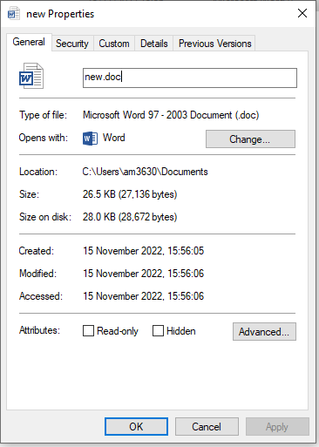

This is a document file to which I will be converting it to a txt file and will be available to view it.

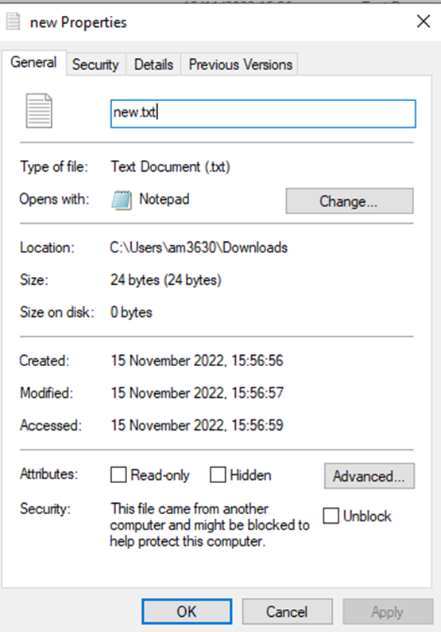

This is a txt file converted from a document file

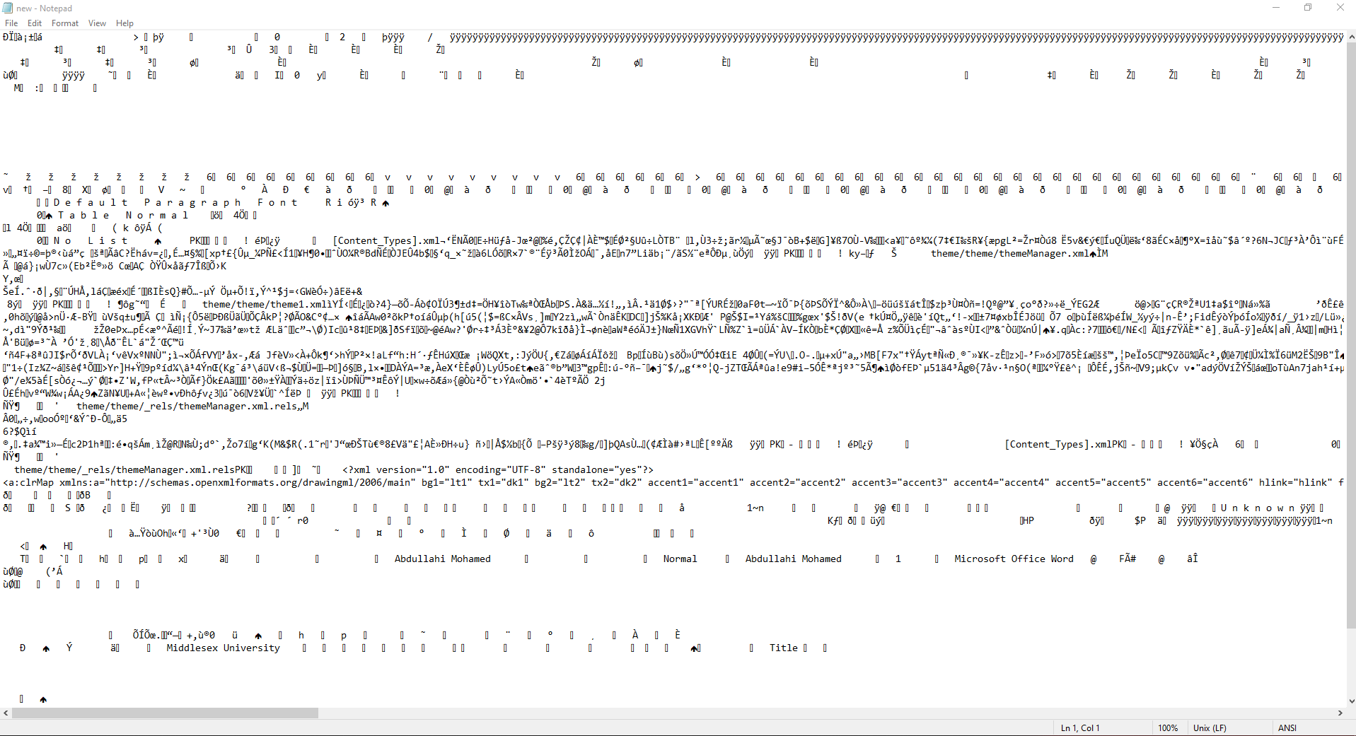

As you can see this is a look at the text file of the document, it shows my full name, what software I am using, my university and data.

1. **Try the same with a .docx document**

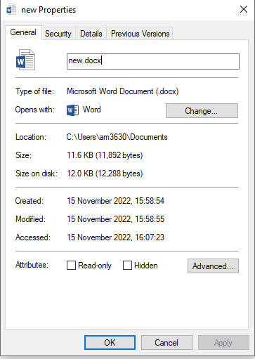

This is a docx file that I will be converting to txt

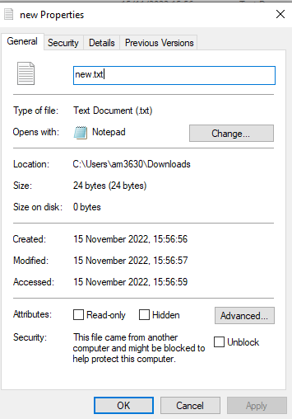

This is the converted txt file from a doc file

1. **Change a .docx extension on a word document to .zip and try to extract**

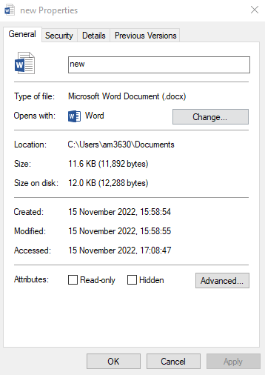

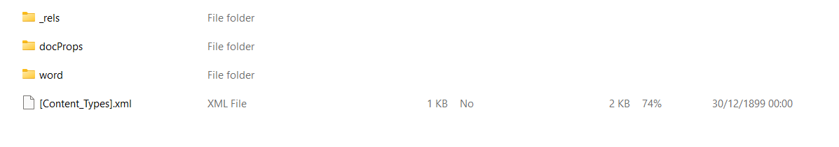

**What do you see?**

Zip is a compressed file that is used to minimize files, I saw an extracted file of which has three folders that contains xml files. Also, all files in the zip are encrypted and protected compared to a docx file that clearly illustrates data.

**Could you recover a message?**

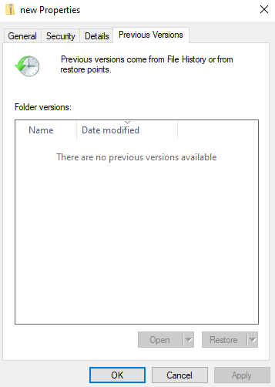

I attempted to recover the message however I could not because it states it in the folder that there are no files available.

1. Try changing a .jpg extension to.txt, open the file in notepad or a similar simple editor

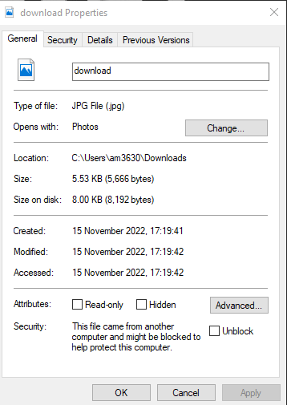

This is a jpg file that I will be converting to a txt file.

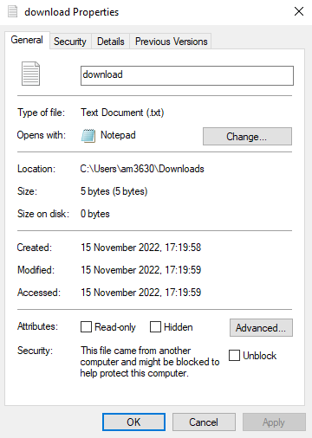

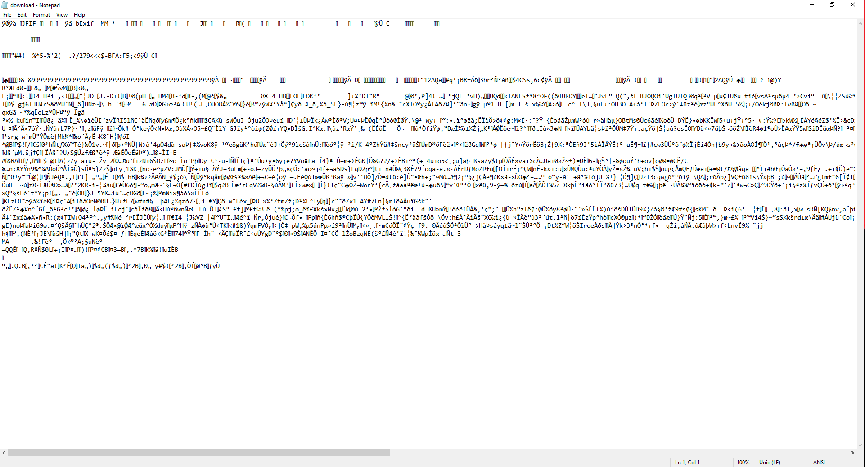This is a txt file that has been converted from a doc.

**5.How can we tell this is a jpg file from the data in the file?**

From the data in the file you can tell this a jpg file because in the first line it states JFIF which is a form of image.

**What metadata can be hidden in a word document?**

* Properties and personal information
* Headers, footers, and watermarks
* XML data
* Hidden text

1. How can you access this?

* Click on file
* Then click info
* Then on the bottom right press show all properties
* Show the name of the owner of the document

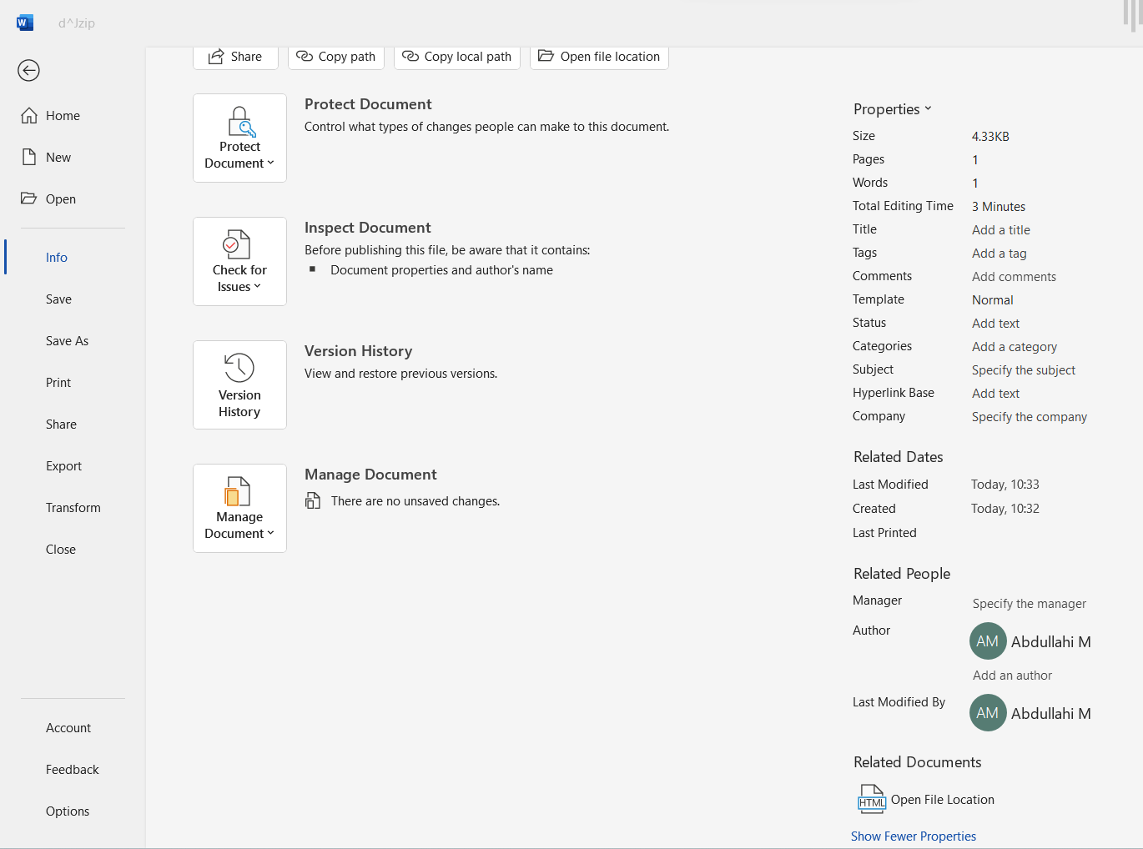

In this screenshot, it shoes my full name, the last time it modified and many more personal data that relates to the file.

The converting tool I used [Convert Files Online - Word, PDF, HTML, JPG And Many More (aspose.app)](https://products.aspose.app/words/conversion/)

**Part 2. Download the password recovery tool**

* [**http://www.freewordexcelpassword.com/index.php?id=download**](http://www.freewordexcelpassword.com/index.php?id=download)
* **I have supplied some files called test 1 and 2**
* **Use Brute Force attacks on these files – Try lowercase letters only**
* **Try all symbols on test one only – what can you observe about time taken to crack the**
* **password in terms of complexity and length.**

**Brute Force Attacks**

It is a cyberattack trying to crack every character to solve the password, they are simple and dependable.

To defend against a brute force attack is to add in a few symbols, set a limit and the length of the password.

**Test one**

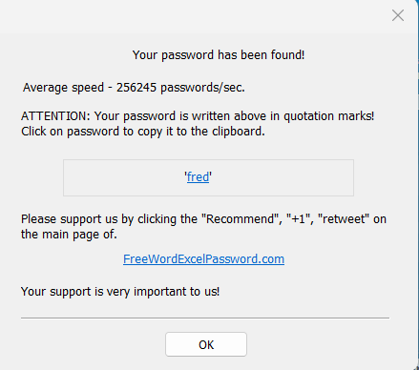

I have downloaded the password recovery tool and I have found the password to assess one, this was done by the generator going through all the possible combinations of the password.

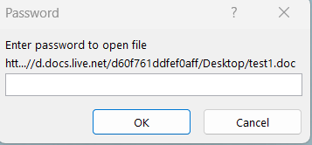

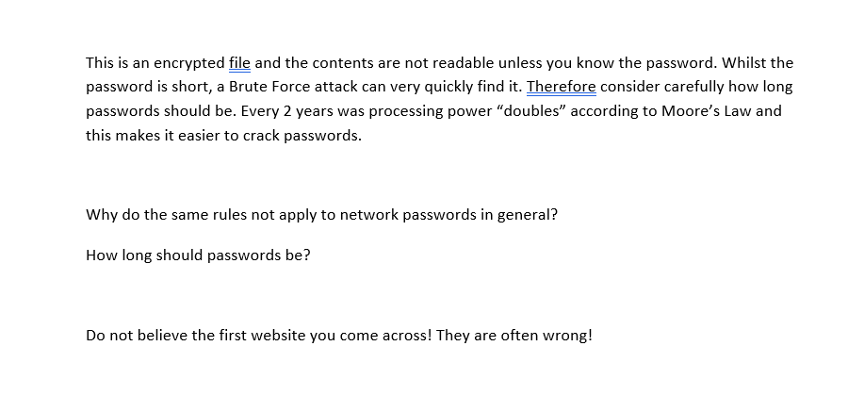It took about 10 minutes for the recovery password tool to find the, it modified all the possible outcomes of all characters then came to result.

The same rules do not apply to a network password because it has a limit which will not allow you to no longer write for a duration.

A password should be 8-16 characters long with a variety of symbols, lower case, upper case, and numbers. This can help keep you secure whilst browsing on the internet due to it being a lot more difficult to figure it out.

**Test two**

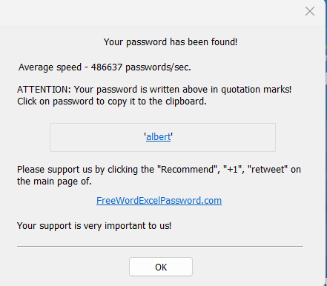

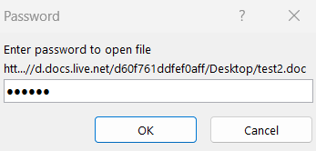

The second test took a lot longer because the password had more characters therefore the generator had to a lot more combination to solve it eventually.

The password was a lot more secure compared to test one because it contains more letters to which if a brute force attack will have to spend a lot more time to trying to find the correct password.

**Part 3. Download the following software and use**

[**https://sourceforge.net/projects/hide-in-picture/**](https://sourceforge.net/projects/hide-in-picture/)

**Use the video demo (steg.avi) to see how it works**

**Try this for yourself – listen to the instructions at the end of the video**

**You should use the software – “Hide in Picture” to perform some simple Steganography.**

**Explain the Process and what you do.**

It is a method of hiding data, text on a file, it is used with encryption as protecting data. It can be used for anything such as digital formats including audio and text. What I did in using steganography is finding a jpeg image then using the software win hip, to hide a secret a message inside the image.

* The first step in steganography is to download winhip which is the software to hide a message behind the photo.
* The second step is select an image that bmp
* The third step is to create a text file and a write a message in it
* The fourth step is to press hide file, select the text file, and set a password
* The fifth step is to retrieve the file writing the correct password
* The last step is that you have activated the message behind the picture

Down below are a few screenshots of the key steps of steganography:

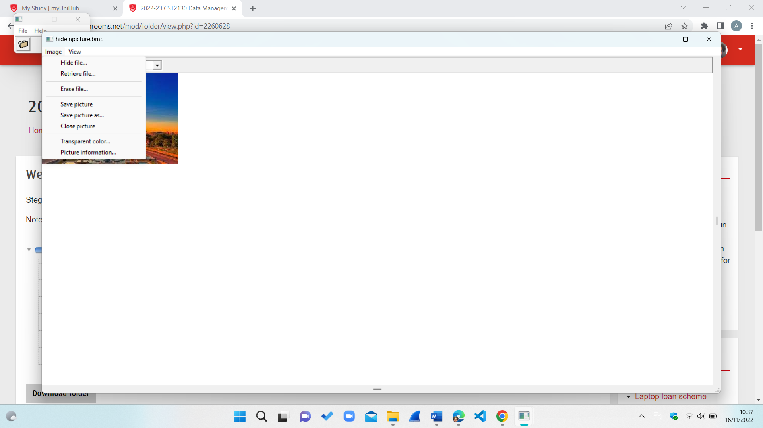

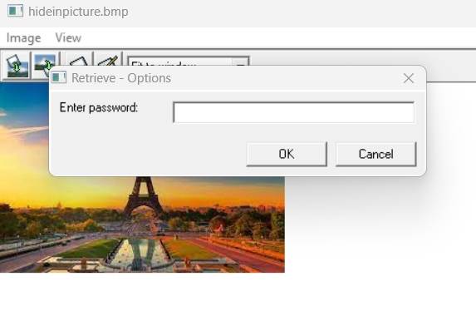

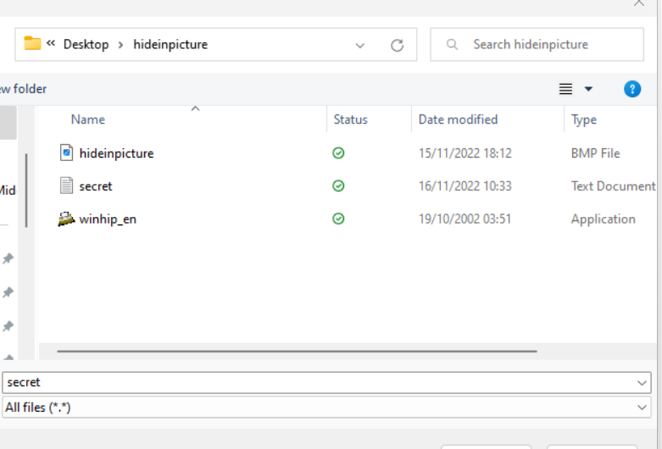

**What types of files can you hide?**

The types of files you can hide in steganography is Video, Text, Audio, Images.

**What difference does the size ratio of the marked file to embedded file make?**

Embedded File: Any form of multimedia file that you might insert or embed into a web page is referred to as an embedded file. Files like graphics and music files fall under this category.

Marked File:  The phrase "filed,” and the date of filing are often inscribed by a clerk or recording officer on a document that has been filed.

The size ratio of a marked file differs to an embedded file because a large image can be filled. Whilst an embedded file can retain a video and graphical to insert whatever.

**How can you tell if this software is Robust or Fragile?**

You can tell if it is robust or fragile through the productivity and duration of hiding a text between images. Through the pace of the steganography in the software that can help you navigate whether it is a suitable one for you.

**What happens if you mark a file that is all white or black?**

if you mark a file that is all white or black, it will be blank, and the message will be invisible to the user however you can still retrieve a message stenographical.

**How secure is steganography as a protection system?**

I do not think steganography is a protective system because if the hacker correctly guesses the hidden text their will had access to the image. However, it can be used as a low-level method to protect data to a certain extent.

**Have there been any recent stories about steganography in the real world?**

Onestory of steganography is a Russian that hid codes in online photos and led to being arrested by the FBI. His reason was he started to practice to steganography then became an expert at it and decided to take it far.

**Can you think of any novel or interesting applications of steganography?**

I managed to research two books that are about steganography to which it talks about the secrets and how it could be apply digitally. The two novels in steganography are, Racheal Thomas, (2021,) Secrets of Steganography, Lerner publication. Frank Y. Shih, (2017), Digital Watermarking and Steganography, CRC Press.

**What other questions do you have and how can you answer them?**

Is it easy to use steganography?

A question I have on steganography is that the process of hiding data behind the image is a lengthy process to which a first-time user may struggle to use it properly.

Is it safe to use steganography?

Yes, you need a password to access it however a hacker can manage to figure out the password meaning it depends on the severity of it.

**References**

NBCNews.com,2010, FBI: Russian spies hid codes in online photos, viewed on July 1st, 2010,

<https://www.nbcnews.com/id/wbna38028696>

Racheal Thomas, (2021,) Secrets of Steganography, Lerner publication and Frank Y. Shih, (2017), Digital Watermarking and Steganography, CRC Press.

**Conclusion**

In this question I have looked through steganography, password recovery and changing files to which I have learnt how to do all three, I believe it has improved my technical skills to which know I am more capable to experiment whilst on my machine.

**Overall Conclusion on Block 1 Coursework**

In this assignment, I have covered plenty of topics such as data transmission, storage, integrity, security, and availability. I believe that my understanding in those topics is much greater than before, I am a lot more capable technically on my laptop. For example, I can fluently use Wireshark because I have understood how to filter, display, and read the network in hexadecimal. These are useful when researching my internet activity, therefore I feel a more confident in my IT knowledge. I set up a disaster recovery plan for a video store to which I gave various advice that covered the business intelligence side of the course. Now I can implement a DRPs into my work going forward as I have learnt if your ever in any sort of disaster in IT you can always trace back and find ways to get out of it. Overall, I found this logbook interesting and became a more observant IT student because now I look at the business side as well as the IT relation.